DRAFT BUDGET
4-29-2026
Fiscal Year
2026-27

1212 SW Simpson; Bend, OR 541-322-6377
Deschutes County RFPD #2
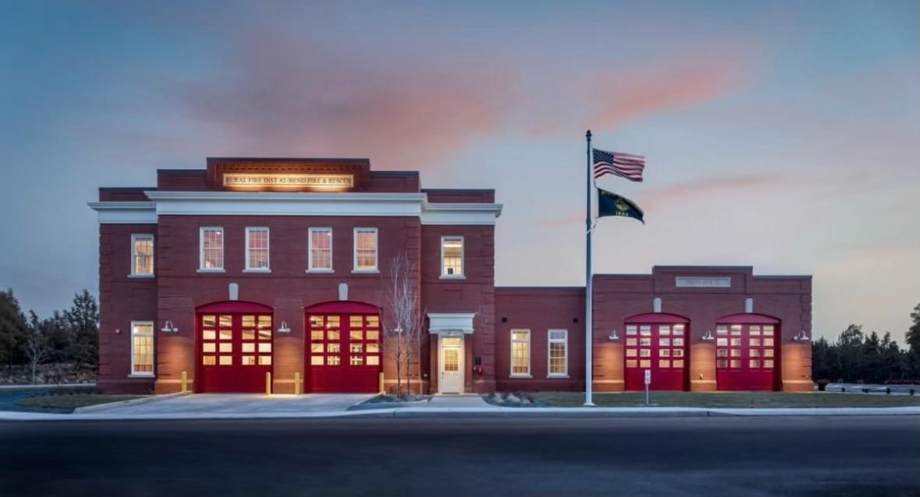

Deschutes County Rural Fire Protection District #2

Introduction of Members
Board of Directors Term Expires
Position 1: Steve Davidson, Secretary/Treasurer 2029
Position 2: Oliver Tatom, Vice President 2029
Position 3: George Roshak, Director 2029
Position 4: Kent Haarberg, President 2027
Position 5: Raymond Miao, Director 2027
Budget Committee Term Expires
T.J. Kennedy 2027
Crosby Grindle 2027
Michael Kirkpatrick 2026
John Pritchard 2027
Vacant 2027
Staff
Roger Johnson, CEO Serving since 2024
Gary Marshall, Executive Director Serving since 2018

From left to right: Roger Johnson, Oliver Tatom, Kent Haarberg, Steve Davidson, George Roshak, Raymond Miao, and Gary Marshall

Budget calendar
DESCHUTES COUNTY RURAL FIRE PROTECTION DISTRICT #2
BUDGET CALENDAR FOR 2026-2027 BUDGET YEAR
- Appointment of Budget Officer February 17th, 2026

- Approve Budget Calendar February 17th, 2026

- Budget Officer Meetings with Accountant and Treasurer February-April, 2026

- Approve Budget Committee and Budget Message April 21st, 2026

- Publish First Notice of Budget Committee Meeting * April 23rd, 2026

- Deliver Proposed Budget to Budget Committee May 5th, 2026

- Publish Second Notice of Budget Committee Meeting* May 6th, 2026

- Budget Committee Meets 12:00 PM After Board Meeting May 19th, 2026

- Budget Committee Meets Again (If Needed) May 26th, 2026

- Publish Notice of Budget Hearing and Proposed Budget June 3rd, 2026

- Budget Hearing at 11:30 AM during Board Meeting June 16th, 2026

- Board Meeting to Enact Resolutions to Adopt Budget,
Make Appropriations, Impose and Categorize Taxes June 16th, 2026

- Post Adopted Budget on Fire District Website June 30th, 2026

- Submit Copies of Required Budget Documents to Assessor June 30th, 2026

- Submit Copies of Required Budget Documents to Clerk June 30th, 2026

*Publishing first and second notice for budget committee meetings will include that there will be an additional Budget Committee meeting on May 26, only if needed.

About the district
Officially established as Deschutes County Rural Fire Protection District #2 in 1952, the district provides fire prevention, protection and suppression services to residents living outside of the Bend city limits. In 1991, the charter was expanded to include emergency medical services (EMS).
The district includes approximately 140 square miles of suburban and forested land and serves approximately 35,000 constituents. Governed by a five-member elected board of directors, the district employs a Chief Executive Officer (CEO) and an Executive Director. The CEO manages the day-to-day operations, fiscal and contract management, and performs administrative and public relations functions on behalf of the district. The Executive Director manages the district’s wildfire policy and annexation programs, and assists the CEO as needed.
The actual delivery of fire and emergency medical services is provided through an Intergovernmental Agreement (IGA) with the City of Bend.

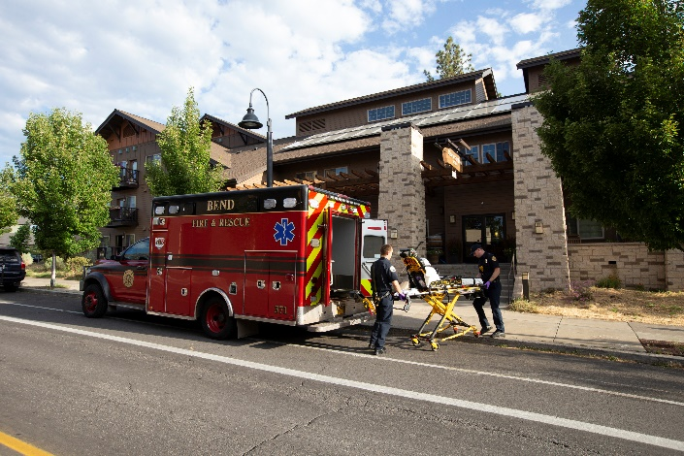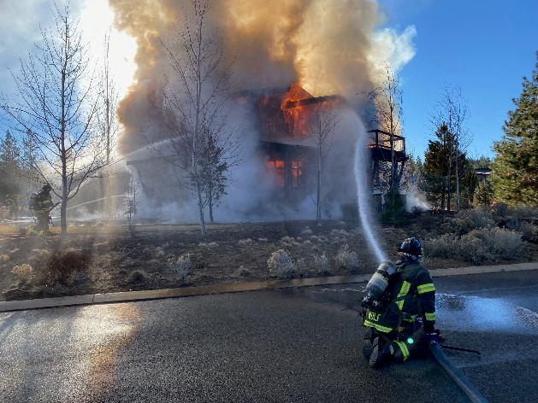

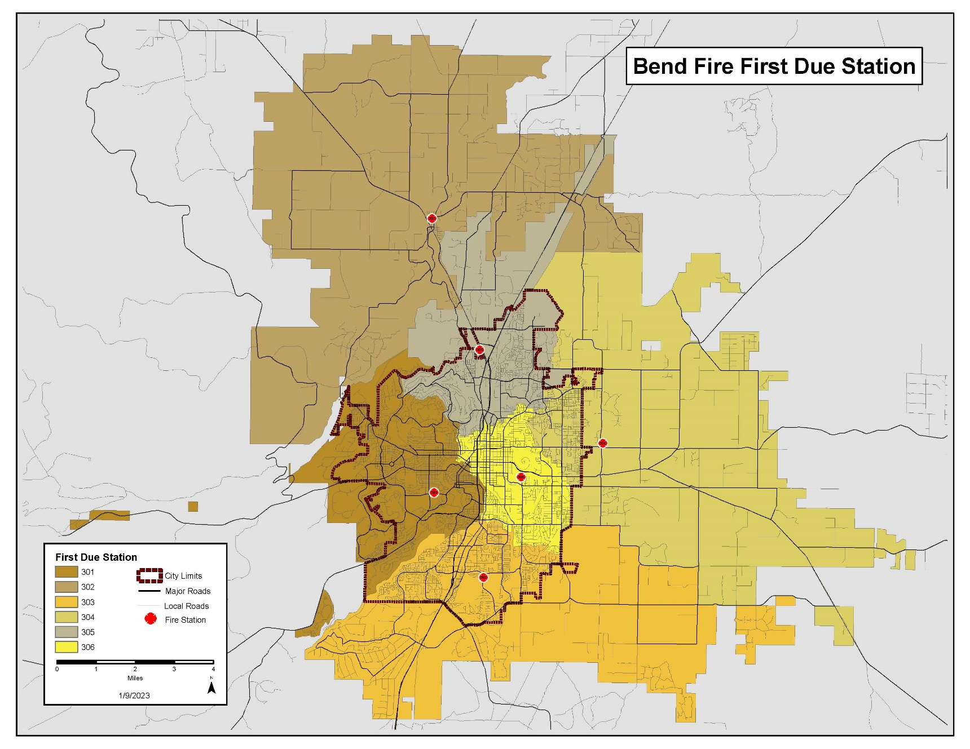
Geographical map

- Station 301, 1212 SW Simpson Ave. Bend Or.
- Station 302, 19850 4th Street Bend, Or. (Tumalo)
- Station 303, 61080 Country Club Dr. Bend, Or.
- Station 304, 62420 Hamby Rd. Bend, Or.
- Station 305, 63377 Jamison Rd. Bend, Or.
- Station 306, 425 NE 15th St. Bend, Or.

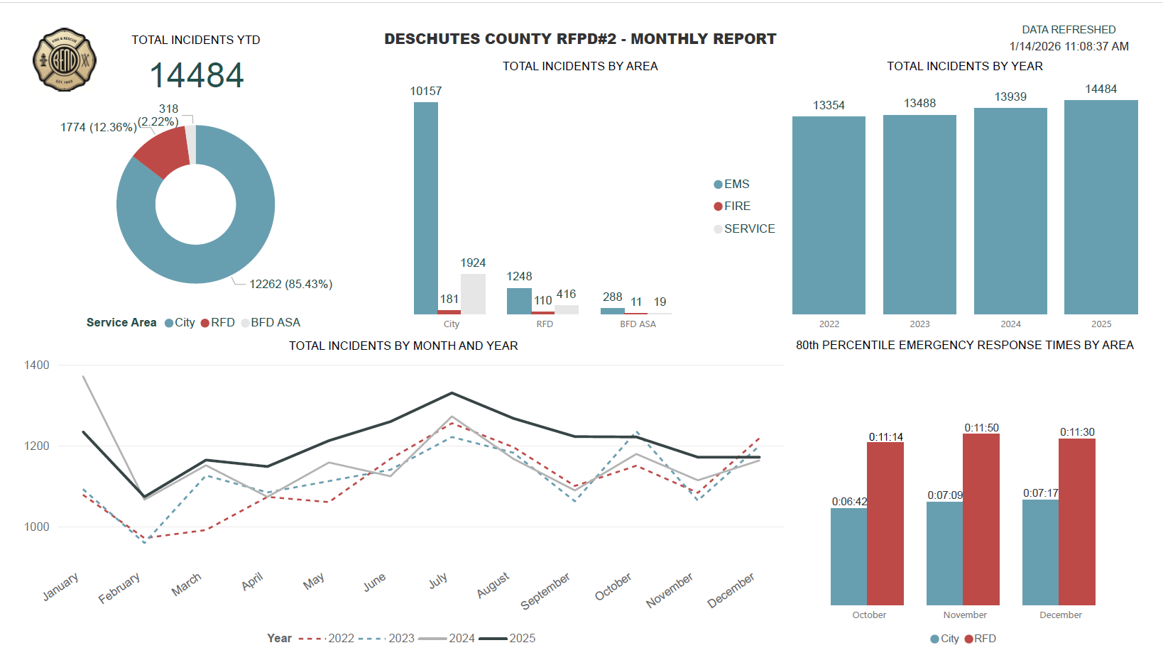

Total emergency calls for the City of Bend Fire and Rescue increased by 3.9% from 2024 to 2025, reaching a total call volume of 14,484. Of these, 81% were EMS related calls, 2% were fire related, and 16% fell under other service categories. Calls within the district accounted for 12.3% of the total, resulting in 1774 calls in 2025.
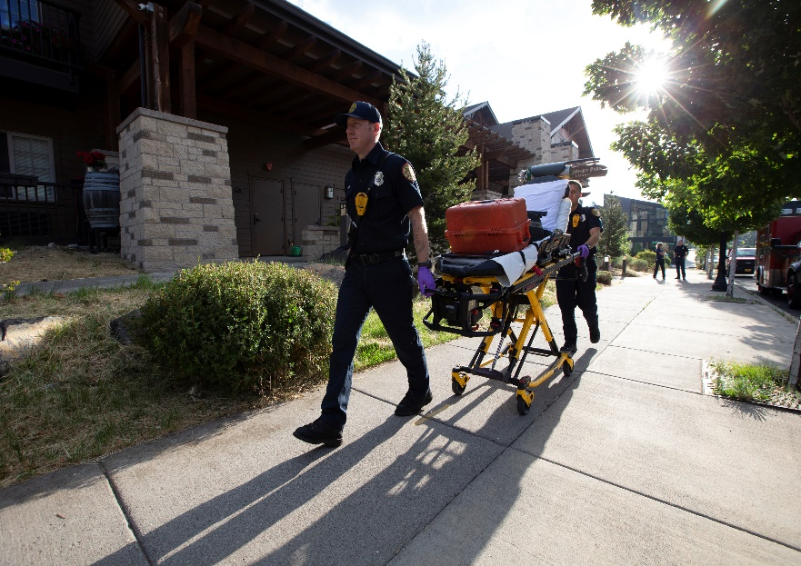

budget message

Budget Committee Members and Citizens,
I am pleased to present the proposed Fiscal Year 2026–2027 budget for Deschutes County Rural Fire Protection District #2. The district remains financially stable and continues to support high-quality emergency services for approximately 35,000 residents in the greater Bend area through its partnership with the City of Bend Fire and Rescue.
The proposed budget maintains the district’s long-standing commitment to responsible financial management while supporting key priorities, including long-term financial sustainability, wildfire risk reduction, community engagement, and continued investment in fire facilities. Property values within the district continue to grow, and voters’ support of the local option levy approved in 2023 continues to provide critical funding for enhanced emergency response services.
The FY 2026–2027 budget reflects careful planning by the district’s budget team and board of directors. It ensures stable funding for fire and emergency services, maintains adequate reserves for financial stability, and supports long-term capital improvements to district fire facilities.
This budget was developed over the past several months by the district’s internal budget team consisting of the CEO/Budget Officer, Executive Director, Board President, Board Secretary-Treasurer, and the district’s contracted accountant.

District organization and financial policies
The district operates under Oregon Revised Statutes (ORS) Chapter 478 as a separate municipal corporation. The district provides fire protection and emergency services through an intergovernmental agreement with the City of Bend.
The district manages its finances in accordance with generally accepted accounting principles (GAAP). The fiscal year begins July 1 and ends June 30 of the following year.
Revenues and expenditures are monitored throughout the year to ensure compliance with the adopted budget and Oregon budget law. Monthly budget-to-actual reports are provided to administrative staff and the district Board of Directors. An independent certified public accountant conducts an annual audit, which is filed with the State of Oregon.

fund structure and financial overview
The district operates two governmental funds:
• Operating Fund.
• Capital Improvement Fund.
A fund is a separate accounting structure used to track specific revenues and expenditures and ensure financial accountability.
Operating Fund
The Operating Fund accounts for property tax revenues, rental income from District-owned facilities, and other miscellaneous revenues. Expenditures include personal services, materials and services, capital outlay, and transfers to the Capital Improvement Fund.
Capital Improvement Fund
The Capital Improvement Fund accounts for beginning fund balance, rental income, transfers from the Operating Fund, and interest earnings. Expenditures include station repairs, facility improvements, and reserves for future capital needs.
The district maintains an ending fund balance sufficient to fund operating expenses at the beginning of each fiscal year to ensure adequate cash flow until property tax revenues are received from the County Treasurer, typically in November. This eliminates the need for short-term borrowing.

2025/2026 Fiscal year review
During FY 2025–2026, the district experienced increased revenues driven by rising assessed property values and continued community growth.
A five-year local option levy approved by voters in 2023 remained in effect during the year, supporting enhanced emergency response staffing and services. The levy rate of $0.76 per $1,000 of assessed value will remain in place through June 30, 2029.
District staff also focused on several organizational priorities:
• Development of a strategic plan.
• Evaluation of long-term funding and governance options.
• Enhancement of wildfire resilience.
• Strengthening community relations.
• Maintaining high-quality emergency services.
Strategic Planning
During FY 2025–2026 the district contracted with the Special Districts Association of Oregon to facilitate a strategic planning process. The planning workshop was held at the district training center and included nineteen leaders representing eleven organizations.
The process resulted in the identification of several priorities that will guide district operations over the next five years, including financial sustainability, governance evaluation, wildfire risk reduction, and expanded community engagement.

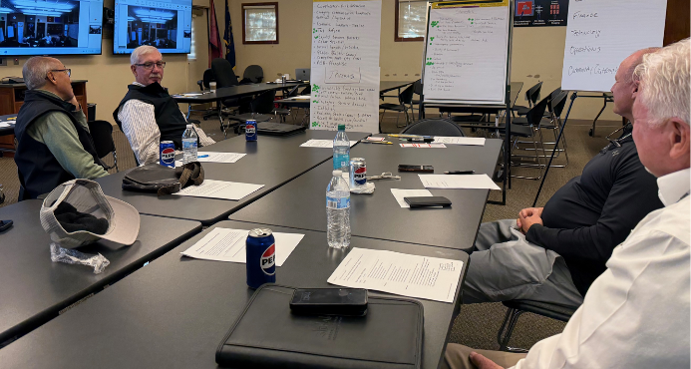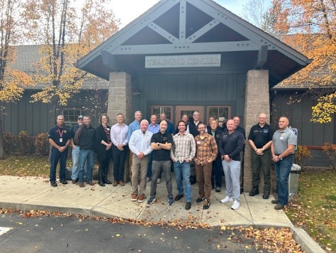
Directors and staff review results of the planning session Full planning group after the session
Long-Term Funding and Governance
In 2024 the district and the city of Bend entered into an updated intergovernmental agreement for fire protection services. The agreement included a commitment to ongoing discussions regarding long-term operations and funding.
A joint long-term funding workgroup was established and met throughout the year. The workgroup will continue meeting through FY 2026–2027 in preparation for a potential renewal of the district’s local option levy in FY 2028–2029.
Enhancing Wildfire Resilience
In 2023 the district was awarded a $280,000 Community Wildfire Risk Reduction Grant to treat 156 acres of land adjacent to the Deschutes River Woods community. The City of Bend Fire Department administered the grant and oversaw project implementation.
Upon completion of the original project, approximately $84,000 in grant funding remained available.
The district and fire department staff identified a manufactured home park adjacent to Deschutes River Woods as an additional area that would benefit from fuel reduction work. In partnership with property owners, mitigation activities included replacing flammable vegetation with noncombustible landscaping materials and removing ladder fuels within five feet of structures. Thirty high-risk properties were treated.
The district also continues to allocate $12,000 annually to support the FireFree wildfire grant program, which assists residents in removing hazardous vegetation around homes and encourages participation in the nationally recognized NFPA Firewise USA program.
Strengthening Community Relations
During FY 2025–2026 the district completed a comprehensive website update, resulting in a modern, ADA-compliant website that improves public access to District information and enhances communication with the community.
Maintaining High-Quality Emergency Services
The City of Bend Fire and Rescue continues to provide high-quality emergency services to district residents. Emergency response activity and service performance can be monitored through the real-time incident dashboard available on the City of Bend’s website

2026/2027 Budget overview
The proposed FY 2026–2027 budget reflects the district’s continued financial support for fire and emergency medical services provided by the City of Bend Fire and Rescue.
The district’s two sources of property tax revenue are:
• A permanent tax rate of $1.4366 per $1,000 of assessed value.
• A $0.76 per $1,000 voter-approved local option levy.
Regarding the permanent tax rate:
• $1.185 per $1,000 is allocated to the Fire & EMS Fund under the service agreement with the City of Bend.
• $0.02 per $1,000 is allocated to the Capital Improvement Fund to support long-term facility maintenance and construction.
For FY 2026–2027, the district anticipates contributing approximately $91,000 from the permanent tax rate to the Capital Improvement Fund, in addition to an estimated $305,000 transfer to support future facility improvements.
The district estimates a property tax collection rate of 96 percent, which is consistent with historical averages. A 3 percent contingency is included in the budget to address unforeseen expenditures that may require a supplemental budget.
A beginning fund balance of $1,508,864 is projected for FY 2026–2027. These reserves will support District operations from July through November, when the majority of property tax revenues are received.

Board goals for fy 2026-2027
The district Board of Directors will focus on several key priorities during the coming fiscal year.

Governance
• Identify service delivery benchmarks for potential inclusion in future intergovernmental agreements.
• Continue active participation in the regional long-term funding workgroup.

Finance
• Develop a multi-year financial sustainability plan.
• Support completion of the EMS rate study and alignment of service charges with operational costs.

Community Outreach and Education
• Implement a Fire Corps volunteer program to support District activities.
• Expand engagement with community organizations and neighborhood groups.

pers participation
The district participates in the Oregon Public Employees Retirement System (PERS). The district currently contributes on behalf of the CEO and Executive Director, both of whom are enrolled in the PERS Work After Retirement Program.
Employees participating in this program do not accrue additional retirement benefits. The district pays the required employer contribution into its PERS account. Oregon PERS rules identify that if an employer employs fewer than five active members on their payroll, PERS will apply the system-wide average rate as the employer contribution rate.
For FY 2026–2027, the district’s employer contribution rate will be 29.13 percent of payroll through 6-30-27.

Key economic factors and assumptions
According to Deschutes County Assessor Scott Langton, property values within the district continue to increase. Based on current projections, assessed value within the district is expected to grow approximately 4.5 percent in FY 2026–2027.
Recent legislative changes may also impact district revenues. House Bill 3940 modified how certain properties within rural fire protection districts are assessed for fire protection taxes. The Deschutes County Assessor’s Office is currently unable to provide updated estimates of the revenue impacts associated with this legislation. Initial estimates prepared when the bill was introduced indicated that approximately 400 properties would be affected, resulting in an estimated $150,000 in additional annual tax revenue for the district. Based on this information, the current budget includes $150,000 in additional revenue attributable to House Bill 3940.

significant budget items
The following assumptions and expenditures may have a significant impact on the FY 2026–2027 budget:
- Increase in City of Bend contract fees due to increases in assessed valuation of the district and to reflect impacts of HB 3940.
- Continuation of the Fire Free Grant program.
- Increases in Fire Prevention/Education to support Fire Corps program.
- Grant expenses are budgeted at $20,000 in anticipation of future grants.
- Election expenses are budgeted at $5,800 for two director positions.
- Miscellaneous expenses were increased for fire station’s defensible space signage.
- Public Relations, including social media, the annual newsletter and the district website.
- Insurance increases are due to industry rate increases.
- Software includes $6,500 to support the City of Bend Fire and Rescue transition to a new predictive software platform.
- $505,000 for planned fire station improvements.
- $10,000 for unplanned fire station repairs.
- A 4% allocation for potential salary increases, subject to Board approval.
- $3,000 each to support the Pipes and Drum Band and the annual Firefighter Awards Banquet.
- Updated contract service rates for audit and accounting services.
- 8% increase in auto insurance premiums.
- 10% increase in health and liability insurance premiums.
- 10% increase in workers compensation insurance premiums.
- PERS rates remain at current level until June 30, 2027.
- Transfer of $305,000 to the Capital Improvement Fund for future facility improvements. $91,000 transfer to the Capital Improvement Fund under the City–District Contract.

budget

operating fund revenue
Beginning Fund Balance $1,508,864
Amount estimated to be carried over from previous year.
Current Year Taxes $6,400,097
Permanent Levy ($1.4366/$1,000 valuation @ 96% collection rate) $6,300,097
HB3940………………………………………………………………………….. $100,000
Current Year Levy Proceeds………………………….. $3,332,920
Operating Levy ($0.76/$1,000 valuation @ 96% collection rate) $3,332,920
HB3940……………………………………………………………………………. $50,000
Previously Levied Taxes Estimated to be Received $40,000
Permanent Levy ($1.4366/$1,000 valuation) $35,000
Operating Levy ($0.76/$1,000 valuation) $5,000
Interest $80,000
Interest from LGIP deposits and First Interstate Bank accounts.
Annexation Fees $1,000
Fees received when properties are annexed into the district. Two@$500.
Rents/Leases $594,300
City of Bend 2026-2027 lease for stations Tumalo & Pilot Butte $594,300
Signs / Candles Income $1,500
Address Sign income @ $25 each $1,325
Battery-operated Candles rented $175
Grant Income $20,000
Other Income $0
Reimbursements, insurance payments, sales of equipment, etc.

operating fund expenditures

Payroll $240,000
Budgeted but not approved raises of 4% for staff. Staff member retiring
12/31/2026. New staff position hired before 12/31/2026.
Payroll Taxes/Benefits $142,300
Payroll Taxes @ 8.0% $19,200
Cell Phone Reimbursement @ $80/month/employee $2,160
PERS @ 29.13% $72,405
Other benefits/taxes $700
Health Insurance $47,835
City of Bend Contract Fees $5,513,255
Base………………….$1.185 / $1,000 assessed valuation…………… $5,413,255
HB3940………………………………………………………………………….. $100,000
City of Bend Levy Fees $3,382,920
$0.76/$1,000 assessed valuation………………………………$3,382,920
HB3940 ..$50,000
Debt Service for stations 302 and 306 $594,300
Full Faith & Credit Obligations, Series 2018, Interest ………………………...$294,300
Full Faith & Credit Obligations, Series 2018, Principal……………………….$300,000
FireFree Program $12,000
Grants for homeowners to create defensible space.
Fire Prevention / Education $2,500
Funds for educating community and school programs in fire prevention.
Grant Expenses $20,000
Expenses related to future grants received.
Office Expenses $4,750
Office supplies, postage, printing.
Association Dues $2,000
OFCA, NFPA, SDAO
Conferences $10,000
Conference fees, and travel expenses for Executive Director and Board Members
Elections $5,800
Elections for two director positions.
Legal $10,000
Attorney and other legal fees.
Audit $15,500
Auditor fees for annual audit.
Recruitment Expenses $2,500
Recruitment expenses for new hire.
Misc Other Expenses $15,800
Swalley Irrigation Fees $1,000
Oregon Gov’t Ethics Commission Fee $500
Bank Fees $75
Pipe and Drum Band $3,000
Awards Banquet $3,000
Fire Station signage explaining defensible work done…………$5,000
Other support for Fire Department $3,225
Public Relations / Social Media $25,000
Newsletter or Website Upgrade $19,000
Newspaper notices/ads $3,000
Other $3,000
Accounting $22,000
Accounting Contractor @ $1,650/mo $19,800
Payroll Service Fees $2,200
Vehicle Expenses $7,500
Fuel, supplies, tires and service for staff vehicle.
Staff Expenses $1,500
Business expenses for Executive Director/CEO.
Uniforms $2,500
Uniforms for E.D./CEO, Board Members, Budget Committee Members and Fire Corps

Board Meetings $6,000
Monthly board meeting lunches $3,870
Monthly agenda meetings $850
Board dues for Lifeflight, Airlink $1,280
Insurance $7,000
District Liability, Property, and Auto Insurance, Worker’s Comp Insurance
Sign Program / Candles $2,000
Supplies for address signs, battery-operated candles for rent.
Communications $1,000
Office phone.
Training Expenses $500
Bend Fire and Rescue training fees for unexpected training needs.
Software $7,500
Predictive Software $6,500
Other $1,000
Capital Outlay $5,000
Budgeted for canopy for vehicle.
Capital Improvement Fund $396,000
Transfers to the Capital Improvement Reserve Fund.
General Operating Contingency $302,000
Funds set aside in contingency for budget anomalies at 3% of operating expenditures.
Unappropriated Ending Fund Balance $1,269,556
Funds used to pay for expenditures prior to receipts of tax revenue in November.

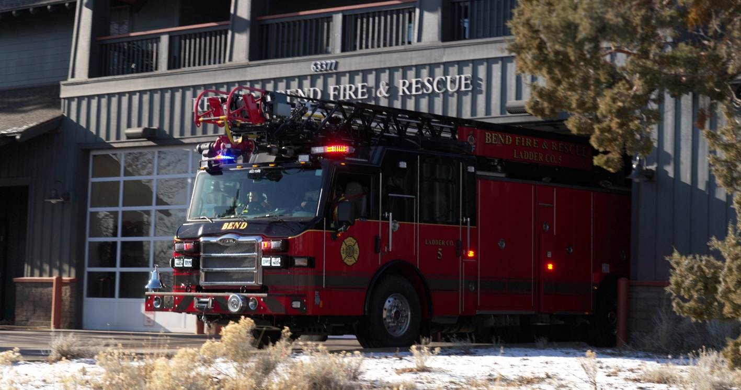

capital improvement fund
The Capital Improvement Fund was authorized and established in 2009 by Board Resolution to prepare for future improvements within the district and reviewed in 2019.
This fund will be reviewed to be continued or abolished in 2029.
Beginning Fund Balance $2,676,969
Estimated amounts carried forward from previous year to pay for future capital improvements.
COB Lease income all buildings except 2019 Tumalo & Pilot Butte….… $396,324
Transferred from other Funds $396,000
Total Funds transferred from Operating Fund to pay for future fire station improvements.
Interest Income $35,000
Interest from LGIP deposits related to Capital Improvement Fund estimated at 3%.
Station Repair Expense $10,000
Expenses related to unexpected fire station repairs.
Station Improvement Expense $505,000
Improvements to remodel fire stations (Example: Cabinets, Windows, Lockers)
Reserved for Future Station Improvements $423,053
Amounts reserved to pay for future station improvements.
Reserved for Future Expenditures $2,566,241
Amounts reserved to pay for future capital improvements & development.

TAX FORMS

The following form will be updated once the budget committee approves the budget….

